Lab 10: Sampling & Quantization

Objective
The 1st half of this Lab experiment is basically about how to sample a continuous time signal into discrete without Aliasing Effect. In the 2nd half, the concept of quantization will be discussed. In addition to this you will the basics of analog-to-digital and digital-to-analog conversions.
Lab Tasks
1. Write a generalized program to sample a Band Limited continuous time signal y=cos(2*pi*f1*t) + cos(2*pi*f2*t) that is limited to fm under the following conditions. Also comment on the results in terms of aliasing effect both in time and frequency domain. Show a Time/Frequency comparison of each part with the original signal.
i. fs=fm
ii. fs>2fm (Oversampling)
iii. fs<fm (Undersampling)

CODE:
clear all;
close all;
clc;

% Signal parameters
f1 = 2; % Frequency of the first component (Hz)
f2 = 3; % Frequency of the second component (Hz)
fm = 5; % Maximum frequency of the band-limited signal

% Continuous-time signal (original)
fs_ct = 1000; % Very high sampling frequency to approximate continuous signal
t_ct = 0:1/fs_ct:1; % Time vector for the continuous signal
y_ct = cos(2*pi*f1*t_ct) + cos(2*pi*f2*t_ct);

% Plot original signal
figure;
subplot(4, 1, 1);
plot(t_ct, y_ct, 'LineWidth', 1.5);
title('Original Signal (Continuous Time)');
xlabel('Time (s)');
ylabel('Amplitude');
grid on;

% Critical Sampling: fs = fm
fs_crit = fm; % Critical sampling frequency
t_crit = 0:1/fs_crit:1; % Time vector for critical sampling
y_crit = cos(2*pi*f1*t_crit) + cos(2*pi*f2*t_crit);

subplot(4, 1, 2);
stem(t_crit, y_crit, 'filled', 'MarkerSize', 4);
hold on;
plot(t_ct, y_ct, 'r--'); % Overlay the original signal
title('Critically Sampled Signal (fs = fm)');
xlabel('Time (s)');
ylabel('Amplitude');
legend('Sampled', 'Original');
grid on;

% Oversampling: fs > 2fm
fs_over = 20; % Oversampling frequency
t_over = 0:1/fs_over:1; % Time vector for oversampling
y_over = cos(2*pi*f1*t_over) + cos(2*pi*f2*t_over);

subplot(4, 1, 3);
stem(t_over, y_over, 'filled', 'MarkerSize', 4);
hold on;
plot(t_ct, y_ct, 'r--'); % Overlay the original signal
title('Oversampled Signal (fs > 2fm)');
xlabel('Time (s)');
ylabel('Amplitude');
legend('Sampled', 'Original');
grid on;

% Undersampling: fs < fm
fs_under = 2; % Undersampling frequency
t_under = 0:1/fs_under:1; % Time vector for undersampling
y_under = cos(2*pi*f1*t_under) + cos(2*pi*f2*t_under);

subplot(4, 1, 4);
stem(t_under, y_under, 'filled', 'MarkerSize', 4);
hold on;
plot(t_ct, y_ct, 'r--'); % Overlay the original signal
title('Undersampled Signal (fs < fm)');
xlabel('Time (s)');
ylabel('Amplitude');
legend('Sampled', 'Original');
grid on;

RESULTS
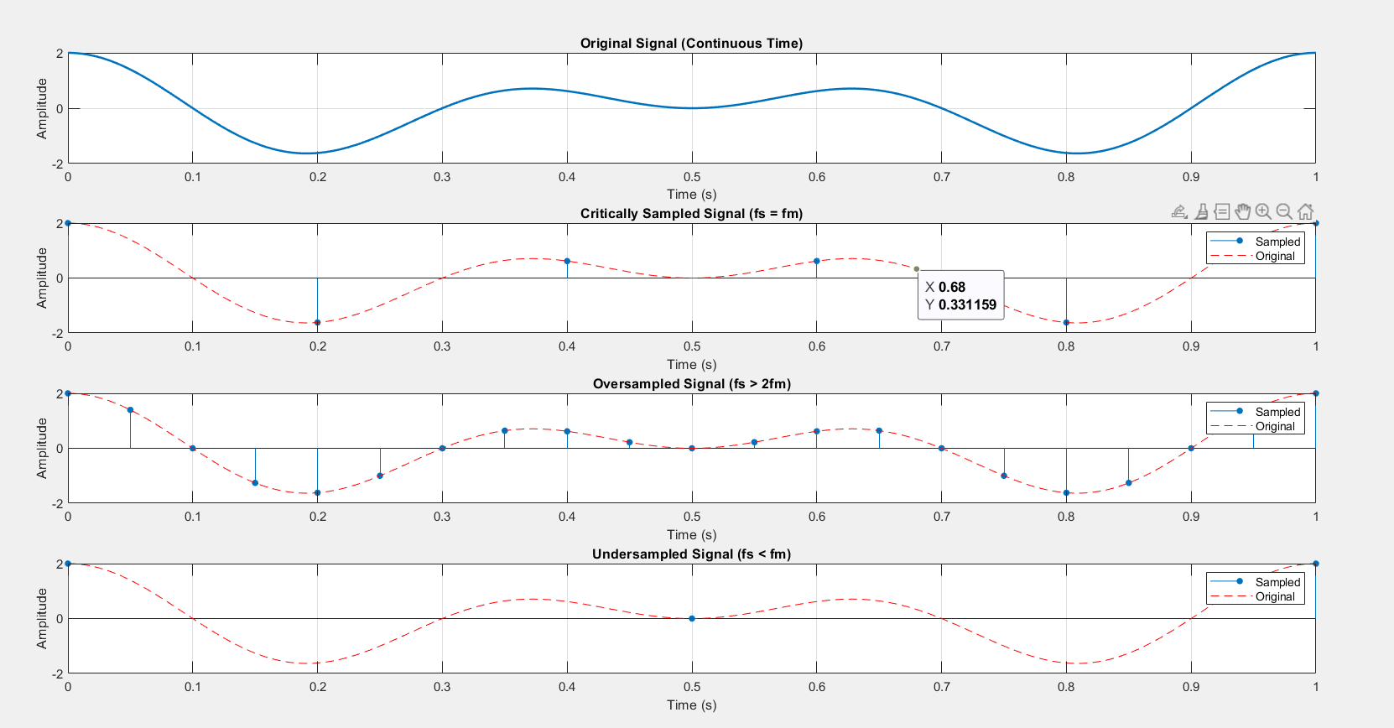
2. Consider an analog signal x(t) consisting of three sinusoids of frequencies of 1 Hz, 4 Hz, and 6 Hz:
x(t)= cos(2πt) + cos(8πt) + cos(12πt)
where t is in seconds. Show that if this signal is sampled at a rate of fs = 5 Hz, it will be aliased with the following signal, in the sense that their sample values will be the same as
xa(t)= 3cos(2πt)
On the same graph, plot the two signals x(t) and xa(t) versus t in the range 0 ≤ t ≤ 2 sec. To this plot, add the time samples x(tn) and verify that x(t) and xa(t) intersect precisely at these samples.
These samples can be evaluated and plotted as follows:
e,g. fs = 5000; T = 1/fs; tn = 0:T:2; plot(tn, xn);
Any observation regarding the comparison of both in frequency domain?
CODE:
clear all;
close all;
clc;

% Sampling frequency and signal parameters
fs = 12; % Sampling frequency (must be greater than 2*f3 to avoid aliasing)
f1 = 1; % Frequency of the first signal (Hz)
f2 = 4; % Frequency of the second signal (Hz)
f3 = 6; % Frequency of the third signal (Hz)

% Time vector for sampling
t = 0:1/fs:2;

% Original signals
y = cos(2*pi*f1*t) + cos(2*pi*f2*t) + cos(2*pi*f3*t); % Combined signal
y1 = 3*cos(2*pi*f1*t); % Additional signal

% Combined signal
xn = y + y1;

% Plot the signals
figure;

subplot(3, 1, 1);
plot(t, y, 'LineWidth', 1.5);
title('Original Signal (y)');
xlabel('Time (s)');
ylabel('Amplitude');
grid on;

subplot(3, 1, 2);
plot(t, y1, 'LineWidth', 1.5);
title('Additional Signal (y1)');
xlabel('Time (s)');
ylabel('Amplitude');
grid on;

subplot(3, 1, 3);
plot(t, xn, 'LineWidth', 1.5);
title('Combined Signal (y + y1)');
xlabel('Time (s)');
ylabel('Amplitude');
grid on;

RESULT:
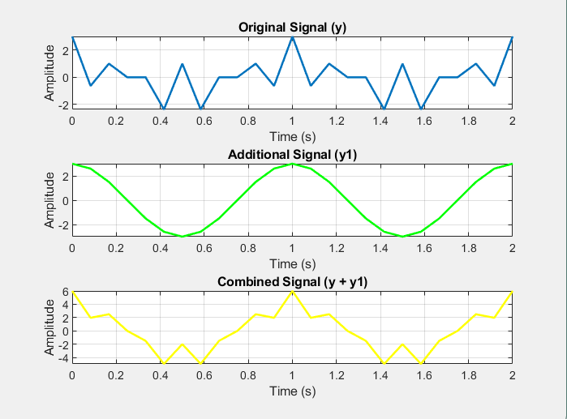
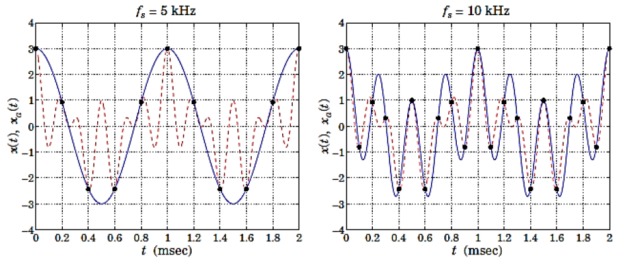
3. Repeat above with fs = 10 Hz. In this case, determine the signal xa(t) with which x(t) is aliased. Plot both x(t) and xa(t) on the same graph over the same range 0 ≤ t ≤ 2 msec. Verify again that the two signals intersect at the sampling instants. Your results should look like following:
Also show how both the signals are aliased in frequency domain.
CODE:
% Signal parameters
f1 = 1; f2 = 4; f3 = 6; % Frequencies of the sinusoids (Hz)

% Time vector for high-resolution plot (continuous signal)
t = 0:0.0001:2; % High-resolution time vector (0.1 ms step)

% Original signal x(t)
x_t = cos(2*pi*f1*t) + cos(2*pi*f2*t) + cos(2*pi*f3*t);

%% Case 1: Sampling at fs = 5 Hz
fs1 = 5; % Sampling frequency
T1 = 1/fs1; % Sampling period
tn1 = 0:T1:2; % Discrete sampling instants

% Discrete-time sampled signal values
x_n1 = cos(2*pi*f1*tn1) + cos(2*pi*f2*tn1) + cos(2*pi*f3*tn1);

% Aliased signal xa(t) for fs = 5 Hz
% All frequencies alias back to 1 Hz (f_a = |f - n*fs|)
xa_t1 = 3*cos(2*pi*f1*t);

% Plot for fs = 5 Hz
figure;
subplot(1, 2, 1);
plot(t*1000, x_t, 'b-', 'LineWidth', 1.5); hold on; % x(t)
plot(t*1000, xa_t1, 'r--', 'LineWidth', 1.5); % xa(t)
stem(tn1*1000, x_n1, 'k', 'filled'); % Sampled points
xlabel('t (msec)');
ylabel('x(t), x_a(t)');
title('Sampling at f_s = 5 Hz');
legend('x(t)', 'x_a(t)', 'Samples');
grid on;

%% Case 2: Sampling at fs = 10 Hz
fs2 = 10; % Sampling frequency
T2 = 1/fs2; % Sampling period
tn2 = 0:T2:2; % Discrete sampling instants

% Discrete-time sampled signal values
x_n2 = cos(2*pi*f1*tn2) + cos(2*pi*f2*tn2) + cos(2*pi*f3*tn2);

% Aliased signal xa(t) for fs = 10 Hz
% f3 = 6 Hz aliases to f3_alias = 10 - 6 = 4 Hz
xa_t2 = cos(2*pi*f1*t) + 2*cos(2*pi*f2*t); % Add aliasing contribution

% Plot for fs = 10 Hz
subplot(1, 2, 2);
plot(t*1000, x_t, 'b-', 'LineWidth', 1.5); hold on; % x(t)
plot(t*1000, xa_t2, 'r--', 'LineWidth', 1.5); % xa(t)
stem(tn2*1000, x_n2, 'k', 'filled'); % Sampled points
xlabel('t (msec)');
ylabel('x(t), x_a(t)');
title('Sampling at f_s = 10 Hz');
legend('x(t)', 'x_a(t)', 'Samples');
grid on;

RESULTS
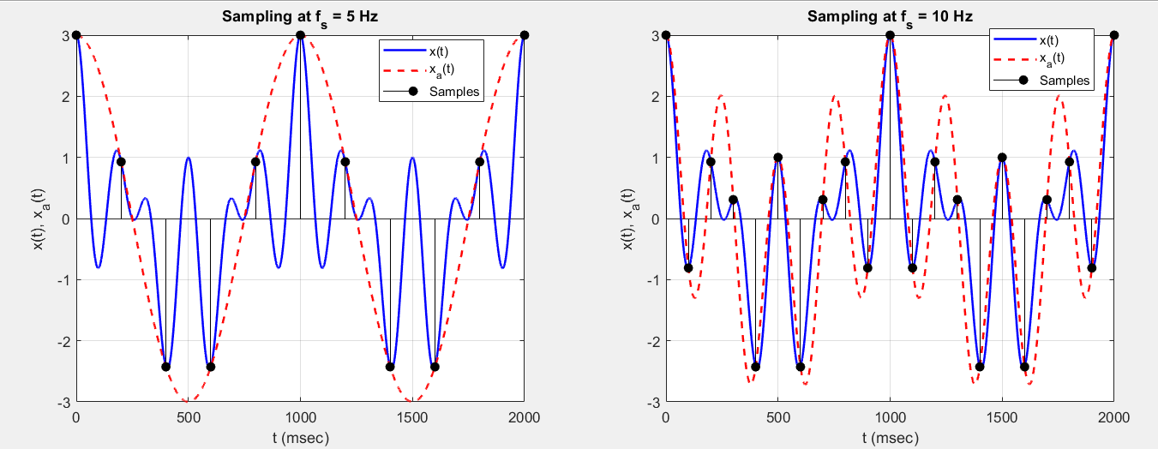

4. Consider a 100 Hz sine wave x(n) is sampled with fS = 4 kHz, N = 64 number of samples and w = 3 bit (word-length).
• What is the number of quantization levels?
• What is the quantization step size Q if the signal is normalized to -1 < x(n) < 1?
• Show graphically how quantization is performed. What is the maximum error for this 3-bit quantizer? What will the trend of quantization error if number of bits are increased to 5?
ANSWER
The number of quantization levels (L) for an w-bit quantizer is given by:
L = 2^{w}
For w = 3
L = 2³ = 8
If the signal
x(n) is normalized to the range −1 ≤ x(n) ≤ 1 , the quantization step size (𝑄Q) is calculated as:
Q = Range/Number of levels = 1−(−1)/𝐿 = 2/8 =0.25
So, the quantization step size Q=0.25.

CODE:
% Parameters
f = 100; % Frequency of sine wave (Hz)
fs = 4000; % Sampling frequency (Hz)
N = 64; % Number of samples
w = 3; % Word length (bits)
L = 2^w; % Number of quantization levels
Q = 2 / L; % Quantization step size

% Time vector and sine wave
n = 0:N-1;
x_n = sin(2*pi*f*n/fs); % Sine wave sampled at fs

% Quantization
x_q = round(x_n / Q) * Q; % Quantized signal

% Plot
figure;
subplot(2, 1, 1);
plot(n, x_n, 'b-', 'LineWidth', 1.5); hold on;
stem(n, x_q, 'r', 'filled', 'LineWidth', 1); % Quantized signal
xlabel('Sample Index');
ylabel('Amplitude');
title('Quantization of Sine Wave');
legend('Original Signal', 'Quantized Signal');
grid on;

% Quantization error
error = x_n - x_q;
subplot(2, 1, 2);
stem(n, error, 'k', 'filled');
xlabel('Sample Index');
ylabel('Error');
title('Quantization Error');
grid on;
RESULTS:
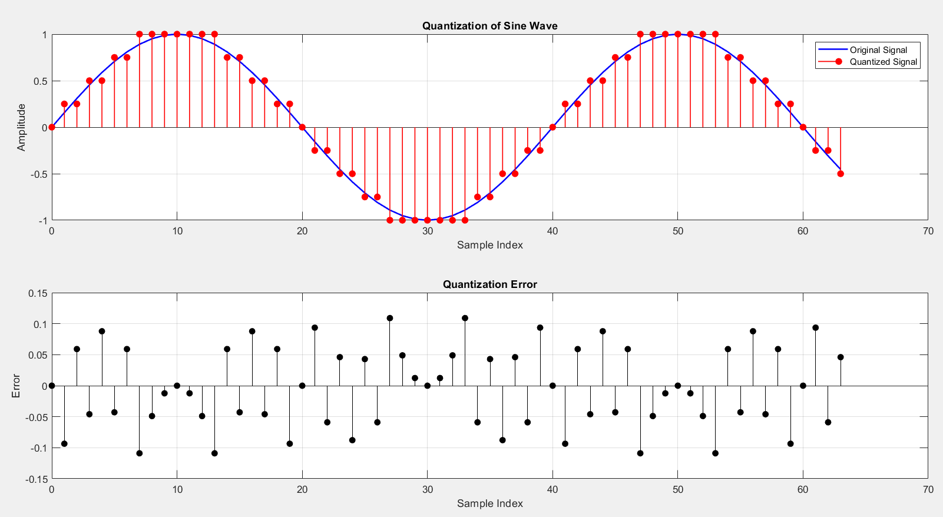
The maximum quantization error (E_{max}​) for a uniform quantizer is:
E_{max​} = Q/2 ​= 0.25/2 ​= 0.125
If the word length (www) increases:
- The number of quantization levels (L) increases, reducing the step size (Q).
- The quantization error decreases as Q gets smaller.
For 𝑤=5:
𝐿 = 2⁵ = 32
Q = 2/32 = 0.0625
E_{max} ​= Q/2 ​= 0.03125
This indicates that increasing the word length improves the resolution of the quantizer and reduces the quantization error.

